## QNORM…actually gives u the Z score associated under some probability under the curve..

R considers the area u r interested is on the left of the curve

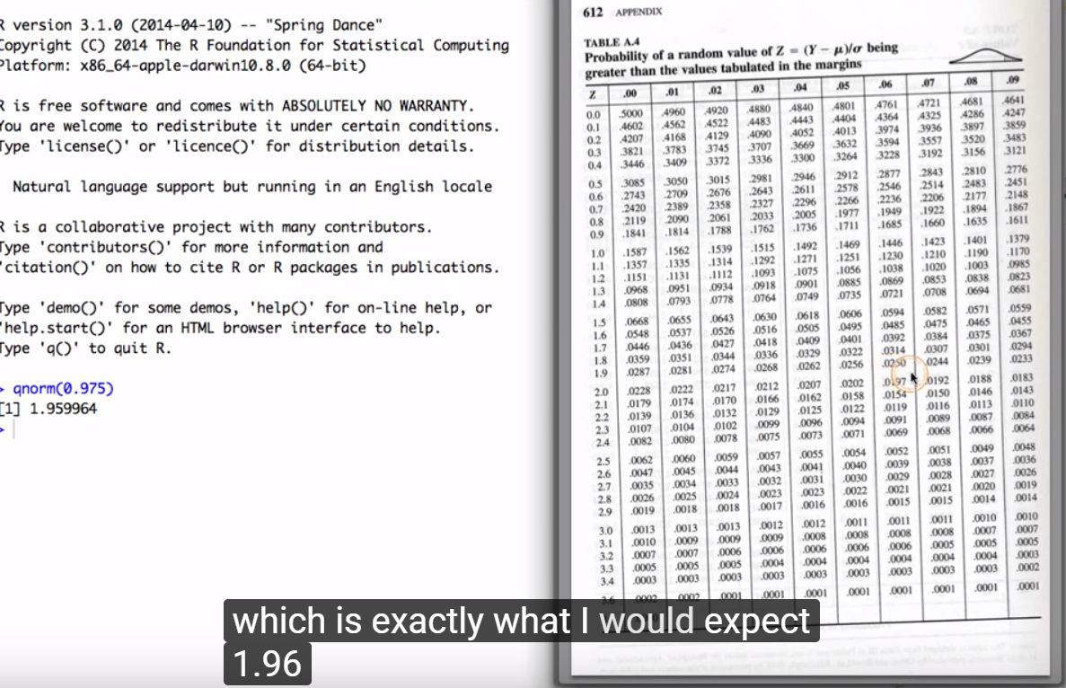

If I check Z score for 1.96 (How many std away from mean)…we see 0.025…which is I expect 1.96 to have 2 and a ½ perecent of the area to right..i.e qnorm(0.025) should give me 1.96 but R gives the area to the right,

<https://www.youtube.com/watch?v=4OlIovpGYEA>

So here we have 0.975 to left and 0.25 to the right.

I can override it using lower.tail=FALSE

So **qnorm(0.025,lower.tail=FALSE)…..(note its QT for T dist)**I get the exact Z score of 1.96

Also

Prnorm() will give you the area associated with the z-score..

Eg pnorm(1.96,lower.tail=FALSE)

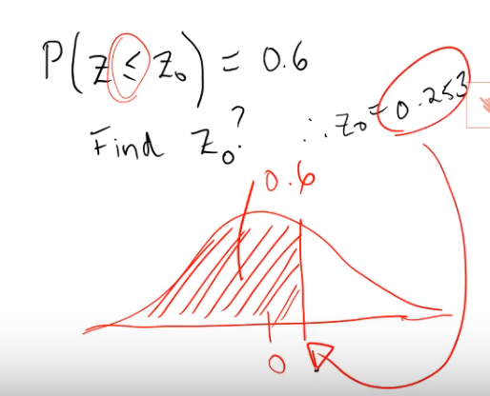

> qnorm(0.6)

[1] 0.2533471

> pnorm(0.2533471)

[1] 0.6

## DBINOM

# probability of answering 5 questions correctly

 We had an exam with 25 questions and 0.2 probability of guessing a question correctly.Five questions are answered correcltly

Dbinom(x,size,prob)

five_correct <- dbinom(5, size = 25, prob = 0.2)

To Find Prob of answering at least 4 Questions right with total 25 questions and prob =0.2

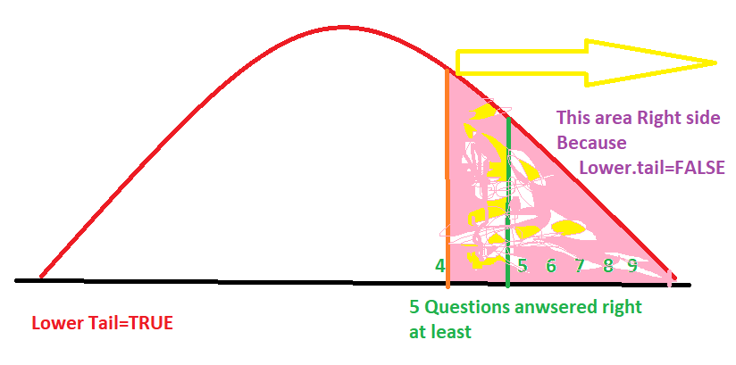

> # calculate the 60th percentile

> qbinom(0.6,25,0.2)

[1] 5